Micro services Architecture on

E-commerce

Graduation Project | CS499 | First Semester 2021/2022

FINAL YEAR GRADUATION PROJECT

Template

Computer Sciences Department

Faculty of Information Technology and Computer Science

Yarmouk University

Irbid, Jordan

Micro services Architecture on

E-commerce

Graduation Project | CS499 | First Semester 2021/2022

**Graduation Project Report**

*BSc Project*

*CS Department*

*Project ID: YUIT-CS–XX-XXX (XX-XXX, Please request the number form CS dept by sending email to computersci@yu.edu.jo)*

**Micro services Architecture on**

**E-commerce**

**Abdelhaleem Alfreihat 2018901070**

**Hashem Mustafa 2018801003**

Department of Computer Science

Faculty of Information Technology and Computer Sciences

Yarmouk University, Jordan

***Contact Information***

*This project report is submitted to the Department of Computer Science at Yarmouk University in partial fulfillment of the requirements for the degree of Bachelor of Information Technology in Computer Science.*

***Author(s):***

*Hashem Mustafa , (2018801003)*

*Address: Jordan, Irbid*

*E-mail:* [*hashemzxm@gmail.com*](mailto:hashemzxm@gmail.com)

*Abdelhaleem Alfreihat , (2018901070)*

*Address: Jordan, Adjlun*

*E-mail:* [*abdfre7at@gmail.com*](mailto:abdfre7at@gmail.com)

***University supervisor(s):***

*Dr.Ameera Jaradat*

*Computer Science*

*Department of Computer Science Internet: http://yu.edu.jo*

*Faculty of Information Technology Phone: +962 2 72711111 Ext. 6710*

*and Computer Science*

*Yarmouk University Fax : +962 2 7211111*

*Jordan*

**Intellectual Property Right Declaration**

*This is to declare that the work under the supervision of Dr.Ameera Jaradat having title “Micro services Architecture on e-commerce” carried out in partial fulfillment of the requirements of Bachelor of Information Technology in Computer Science, is the sole property of the Yarmouk University and the respective supervisor and is protected under the intellectual property right laws and conventions. It can only be considered/ used for purposes like extension for further enhancement, product development, adoption for commercial/organizational usage, etc., with the permission of the University and respective supervisor.*

*This above statement applies to all students and faculty members.*

*Date: January 2022*

|  |  |
| --- | --- |
| ***Author(s):*** | |
| *Name: Hashem Mustafa* | *Signature: _____________________* |
|  |  |
| *Name: Abdelhaleem Alfreihat* | *Signature: _____________________* |
|  |  |

***Supervisor(s):***

*Name: Dr.Ameera Jaradat Signature: _____________________*

**Anti-Plagiarism Declaration**

*This is to declare that the above publication produced under the supervision of Dr.Ameera Jaradat having title “Micro services Architecture on e-commerce” is the sole contribution of the author(s) and no part hereof has been reproduced illegally (cut and paste) which can be considered as Plagiarism. All referenced parts have been used to argue the idea and have been cited properly. I/We will be responsible and liable for any consequence if violation of this declaration is proven.*

Date: *January 2022*

**Author(s):**

Name: *Hashem Mustafa* Signature: _____________________

Name: *Abdelhaleem Alfreihat* Signature: _____________________

**ACKNOWLEDGMENTS**

*I would like to express my sincere gratitude to several teaching staff individuals for supporting me throughout my study period. First, I wish to express my sincere gratitude to my supervisor, Dr.Ameera Jaradat, for her enthusiasm, patience, insightful comments, helpful information, practical advice and unceasing ideas that have helped me tremendously at all times in my research and writing of this thesis. her immense knowledge, profound experience and professional expertise in computer Science has enabled me to complete this research successfully. Without her support and guidance, this project would not have been possible.*

***Abstract***

Below is a sample for Abstract page. It follows the Acknowledgement page.

**ABSTRACT**

[Abstract text]

**Keywords**: 3-4 keywords, maximum 2 of these from the title, which starts one line below the Abstract.

***Table of Contents***

Below is a sample for Contents page. It follows the Abstract page.

**TABLE OF CONTENTS**

[Table of contents]

***GP Report Chapters***

From here onwards this document should be organized into different chapters specific to each project. Rest of the section outlines chapters to be included and the recommended contents of each chapter.

**Chapter 1 INTRODUCTION**

1.1 Purpose of the Project

1.2 Purpose of this Document

1.3 Overview of this Document

1.4 Existing System

1.4.1 Existing system description

1.4.2 Problems in the existing system

**Chapter 2 SYSTEM ANALYSIS**

2.1 Data Analysis

2.1.1 Data flow diagrams

2.1.2 System requirements

2.1.2.1 Clients, customers, and users (Use-case Diagrams)

2.1.2.2 Functional and data requirements

2.1.2.3 Non-functional requirements

2.1.2.3.1 Look and feel requirements.

2.1.2.3.2 Usability requirements

2.1.2.3.3 Security requirements

2.1.2.3.4 Performance requirement

2.1.2.3.5 Portability requirements

2.1.3 Class Diagrams

2.1.4 Proposed Solutions

2.1.5 Alternative Solutions

**Chapter 3 DESIGN CONSIDERATIONS**

3.1 Design Constraints

3.1.1 Hardware and software environment

3.1.2 End user characteristics

3.2 Architectural Strategies

3.2.1 Algorithm to be used

3.2.2 Reuse of existing software components

3.2.3 Project management strategies

3.2.4 Development method

3.2.5 Future enhancements/plans

**Chapter 4 SYSTEM DESIGN**

4.1 System Architecture and Program Flow

4.1.1 Major modules

4.1.2 Sub modules

4.2 Detailed System Design

4.2.1 Detailed component description

**Chapter 5 IMPLEMENTATION AND VALIDATION**

**Appendix A CODE**

**Appendix References**

CHAPTER 1 INTRODUCTION

Micro services - also known as the micro service architecture - is an architectural style that structures an application as a collection of services that are

* Highly maintainable and testable
* Loosely coupled
* Independently deployable
* Organized around business capabilities
* Owned by a small team

The micro service architecture enables the rapid, frequent and reliable delivery of large, complex applications. It also enables an organization to evolve its technology stack.

**1.1 Purpose of the Project**

The goal of this project is to implement micro services architecture and focus on the infrastructure on a particular system, which offers many advantages for large and complex systems, and can be implemented on almost any complex system.

**1.2 Purpose of this Document**

My reason for writing this document is to explain in more details about our implementation.

**1.3 Overview of this Document**

This document explains the architecture, software, technology stack, and how it is going to work.

**1.4 Existing System:**

**1.4.1 Existing system description**

Most of the systems today built on monolithic architecture which are designed to handle multiple related tasks. They’re typically complex applications that encompass several tightly coupled functions.

**1.4.2 Problems in the existing system**

* **Scalability Is Limited.**
* **Reliability Issues.**
* **Lack of Flexibility**
* Large code base
* Tight coupling between components, as everything is in one application

CHAPTER 2 SYSTEM ANALYSIS

**2.1 Data Analysis**

**2.1.1 Data flow diagrams**

Overview of the system

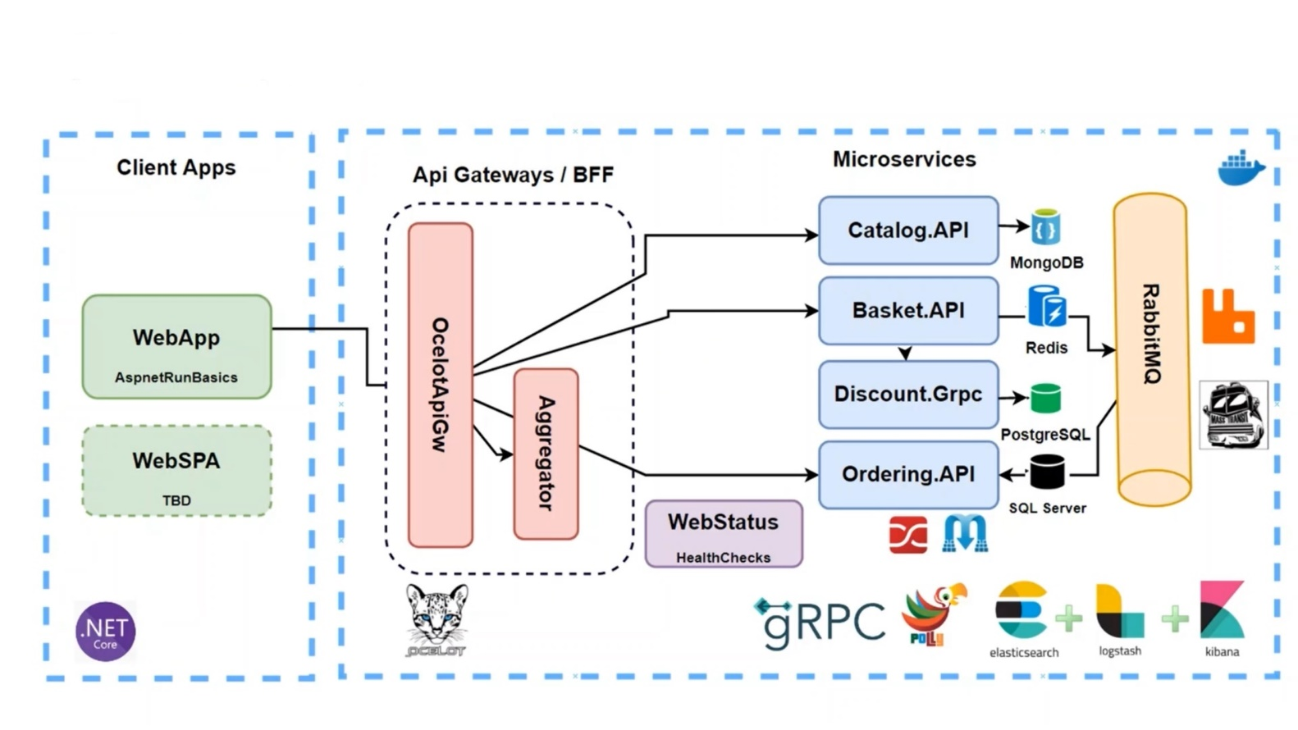

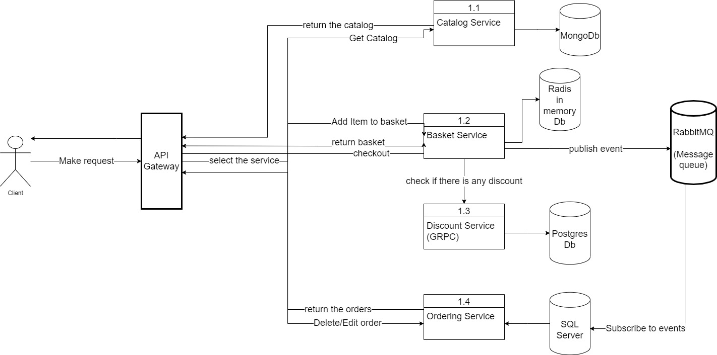

**2.1 Data Analysis**

**2.1.2.1 (Use-case Diagrams)**

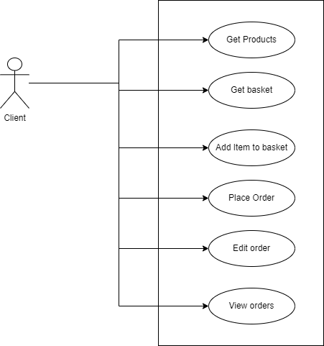

**2.1.2.2 Functional and data requirements**

|  |
| --- |
| Basket.API Service Functional requirements |
| User Get his Basket data |
| User Update basket |
| User Delete basket |
| User Checkout and place the order |
| Call discount GRPC service to check for discount when add item to basket |

|  |
| --- |
| Catalog.API Service Functional requirements |
| User Get the products list |
| Get specific product by id |
| Get product list based on category |
| Update product |

|  |
| --- |
| Discount.API Service Functional requirements |
| Get discount amount on product based on product name |
| Delete discount |
| Update discount |
| Create discount |

|  |
| --- |
| Discount.GRPC Service Functional requirements.  Same as API services but using GRPC protocol for internal communication |
| Get discount amount on product based on product name |
| Delete discount |
| Update discount |
| Create discount |

|  |
| --- |
| Ordering.API Service Functional requirements |
| Get user orders |
| Update order |
| Delete order |

**2.1.2.3 Non-functional requirements**

**2.1.2.3.1 Look and feel requirements.**

* The user interface must be very simple and user friendly

**2.1.2.3.1 Usability requirements**

* The system should be easy to use by all users
* The users will be familiar with the system and all its functions within 30 minutes